Name: Michael Sullivan | Contact Info: msullivan@vikingmail.org | Date: October 2017

Lesson Title : From Motor to Generator | Unit #:  1 | Lesson #:  2 | Activity #:  4
Activity Title: Marketing Video for Generator

Estimated Lesson Duration: | 3 weeks
Estimated Activity Duration: | 1 week

Setting: | STEM workshop & computer lab

Activity Objectives:
Students will script and produce a short video highlighting the design features of their generator and why it is a good solution for the problem as defined through Activity 1.

Activity Guiding Questions:
- Which features distinguish between a good generator design and a great one?
- How does the generator design use mechanical advantage to perform?
- How does the generator leverage the relationships shown in Ohm’s law to convert mechanical energy into electrical energy?
- What is the purpose of a brief marketing video?
- To whom might such a video be shown?
- How is a 60-second marketing video structured differently than a 10-second marketing video or a 5-minute marketing video?
- What elements must be included in any effective marketing video about an engineering solution? (NOTE: nearly everything else should be edited out of the final product)
- How could you use the EDP to produce a marketing video?

Next Generation Science Standards (NGSS)
Science and Engineering Practices (Check all that apply) | Crosscutting Concepts (Check all that apply)
☒ Asking questions (for science) and defining problems (for engineering) | ☒ Patterns
☐ Developing and using models | ☒ Cause and effect
☐ Planning and carrying out investigations | ☒ Scale, proportion, and quantity
☒ Analyzing and interpreting data | ☒ Systems and system models
☐ Using mathematics and computational thinking | ☒ Energy and matter: Flows, cycles, and conservation
☒ Constructing explanations (for science) and designing solutions (for engineering) | ☒ Structure and function.
☒ Engaging in argument from evidence | ☐ Stability and change.
☒ Obtaining, evaluating, and communicating information

Ohio’s Learning Standards for Science (OLS)
Expectations for Learning - Cognitive Demands (Check all that apply)
☐ Designing Technological/Engineering Solutions Using Science concepts (T)
☒ Demonstrating Science Knowledge (D)
☒ Interpreting and Communicating Science Concepts (C)
☒ Recalling Accurate Science (R)

Ohio’s Learning Standards for Math (OLS) and/or
Common Core State Standards -- Mathematics (CCSS)
Standards for Mathematical Practice (Check all that apply)
☒ Make sense of problems and persevere in solving them | ☒ Use appropriate tools strategically
☒ Reason abstractly and quantitatively | ☐ Attend to precision
☒ Construct viable arguments and critique the reasoning of others | ☒ Look for and make use of structure
☐ Model with mathematics | ☐ Look for and express regularity in repeated reasoning

Unit Academic Standards (NGSS, OLS and/or CCSS):

- HS-PS3-2: Develop and use models to illustrate that energy at the macroscopic scale can be accounted for as a combination of energy associated with the motion of particles (objects) and energy associated with the relative positions of particles (objects).
- HS-PS3-3. Design, evaluate, and/or refine a solution to a complex real-world problem, based on scientific knowledge, student-generated sources of evidence, prioritized criteria, and tradeoff considerations, to convert one form of energy into another form of energy.
- HS-PS3-5. Develop and use a model of two objects interacting through electric or magnetic fields to illustrate the forces between objects and the changes in energy of the objects due to the interaction.

Materials:

- Student smart phones
- Classroom computers with Movie Maker software
- Second- or third-generation prototypes from Activity 3
- Testing hardware from Activity 3 (including LEDs and multimeters)

Teacher Advance Preparation:
Ensure students still have access to all tools and supplies from Activity 3 and that there will be access to quiet, well-lit spaces for students to record videos.

Activity Procedures:

- Permit students additional time to ensure they complete at least one iteration (second prototype) of their generator from Activity 3
- Show sample of a brief marketing video from Kickstarter, such as this 2-minute video on universal chargers, noting that most Kickstarter videos are between 1.5 and 2.25 minutes in duration, but that they also tend to be professional videos; students will be expected to produce a video at least 50 seconds in duration and no more than 70 seconds in duration.
- Show students which areas are to be used for capturing their video, with the understanding that the teams need to deconflict so that their narrations do not interfere with one another. Have students reserve spaces and times.
- Provide students with a self-grading rubric for their videos to help them structure the content.
- Push students to record a 60-second improvised video as their baseline from which they should be iteratively improving as they move it toward fidelity with the rubric.
- If a team seems to be ahead of the rest of the class (which will inevitably happen), award them status as “marketing consultants” and have them assist teams that are struggling. They are not permitted to directly perform any of the tasks of the other teams, but they should provide supportive suggestions and share tips for what made their work go more smoothly.
- On the final day of the activity, provide students with an opportunity to upload their finished videos and show them to the whole class. Create online surveys based on the rubric so that students can crowd-assess each video as they watch.
- Assign 10-minute exit tickets requiring each student to identify a design choice they admire by another team and a design choice they changed between their first prototype and their final prototype, making appropriate use of unit vocabulary and concepts to explain why those two design choices made good sense.

Formative Assessments:

Teams will submit their initial 60-second improvised videos. Have the students self-report where their unscripted videos fall short against the rubric. Provide them with validation or gentle correction so they know whether they understand the objectives and how to achieve them.
Rubric:
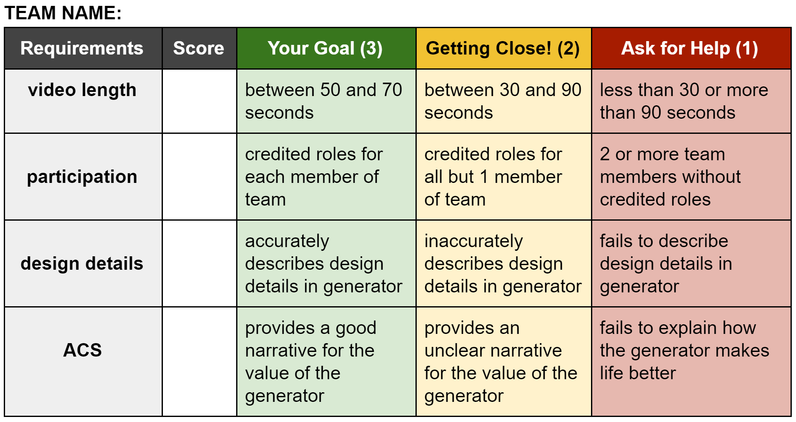

Summative Assessments:

Teams will submit finished videos that will be graded against the rubric. On the following day, the teacher will reveal to the class how closely the crowd-sourced grades matched the teacher-issued grades.
Individually, students will be assessed on their ability through the final exit ticket to articulate two design choices in terms of the concepts learned during the unit.
Differentiation:

This activity allows students to improvise and obtain quick results, simultaneously providing them with instant feedback as a self-administered pre-test. In this way they generate student-derived scaffolding/structure to complete the activity. In addition, the students will have to use imagery and sound to communicate (and thereby process) content. Students will also have opportunities to play to their strengths (direction, on-camera narration, editing, scripting, etc.) as well as an opportunity to step away from their teams and submit written work as individuals (through the exit ticket).
Reflection: After the activity is taught, reflect upon the successes of teaching this Activity in 5 or more sentences. Include a description of what Differentiation strategies worked and what should be changed – justify by presenting evidence and results.

This activity was not attempted in our inaugural running of the unit. Problems experienced during the 3rd activity turned student sentiment heavily against the unit and part of being student-led is recognizing when students have stopped learning and are fixated on their frustrations. The unit had already run for 5 weeks and students were burned out on the challenge.

This activity has the advantage of being content-neutral. As such, even though we did not attempt it as part of the electromagnetism unit, we will be attempting it as part of our current unit on the science of soap, in which the students are developing their own soap recipes as part of a fictionalized business model for a cottage industry selling through Etsy. This activity has solid opportunities for self-differentiation (whether scripting, filming, directing, doing on-camera work, or building props or set-pieces) and requires coordination among team members to ensure that the content of the unit is accurately and completely portrayed.

